***Maintain Efficient Process Utilization on Windows***

***Jenitha Reddy Kurra***

***18Z327***

1. **Terminating a specific process**
2. To terminate a process, search for the process using **Get-Process -Name [process_name].** This will specify the process ID and other attributes of the process
3. Terminate the process using **taskkill /F /PID [process_id]**. Termination can be verified using **Get-Process -Name [process_name]**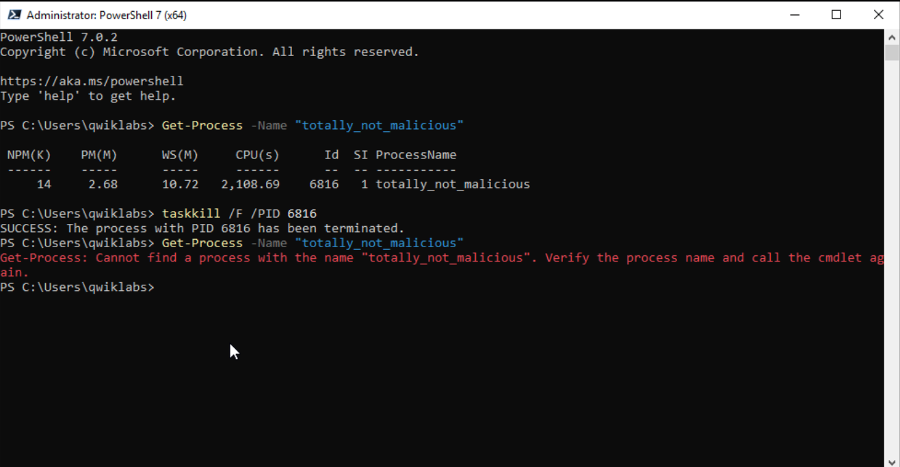

**2. Terminating multiple processes**

1. To find all the processes containing the string “razzle”, search: **Get-Process -Name “*razzle*”**
2. Terminate the processes one at a time using **taskkill /F /PID [process_id]**. Termination can be verified using **Get-Process -Name “*razzle*”**.